UNITED STATES
SECURITIES AND EXCHANGE COMMISSION
WASHINGTON, D.C. 20549

FORM 8-K
CURRENT REPORT
Pursuant to Section 13 or 15(d) of the Securities Exchange Act of 1934
Date of Report (Date of earliest event reported): October 6, 2026
Black Hills Corporation
(Exact name of Registrant as Specified in Its Charter)
________
South Dakota | 001-31303 | 46-0458824
(State or Other Jurisdiction  of Incorporation) | (Commission File Number) | (IRS Employer  Identification No.)
7001 Mount Rushmore Road
Rapid City, South Dakota |  | 57702
(Address of Principal Executive Offices) |  | (Zip Code)
Registrant's Telephone Number, Including Area Code: 605 721-1700

Name
(Former Name or Former Address, if Changed Since Last Report)

____________________________
Check the appropriate box below if the Form 8-K filing is intended to simultaneously satisfy the filing obligation of the registrant under any of the following provisions:
☐ Written communications pursuant to Rule 425 under the Securities Act (17 CFR 230.425)
☐ Soliciting material pursuant to Rule 14a-12 under the Exchange Act (17 CFR 240.14a-12)
☐ Pre-commencement communications pursuant to Rule 14d-2(b) under the Exchange Act (17 CFR 240.14d-2(b))
☐ Pre-commencement communications pursuant to Rule 13e-4(c) under the Exchange Act (17 CFR 240.13e-4(c))
Securities registered pursuant to Section 12(b) of the Act:
Title of each class | Trading  Symbol(s) | Name of each exchange on which registered
Common stock of $1.00 par value | BKH | The New York Stock Exchange
Indicate by check mark whether the registrant is an emerging growth company as defined in Rule 405 of the Securities Act of 1933 (§ 230.405 of this chapter) or Rule 12b-2 of the Securities Exchange Act of 1934 (§ 240.12b-2 of this chapter).
Emerging growth company ☐
Indicate by check mark whether the registrant is an emerging growth company as defined in Rule 405 of the Securities Act of 1933 (§ 230.405 of this chapter) or Rule 12b-2 of the Securities Exchange Act of 1934 (§ 240.12b-2 of this chapter). ☐

Item 7.01 Regulation FD Disclosure.
On October 6, 2026, Black Hills Corporation announced the execution of definitive agreements to serve Google's data center project in Cheyenne, Wyoming. A copy of the press release is furnished as Exhibit 99.1 to this Form 8-K.

Item 9.01 Financial Statements and Exhibits.

Exhibit No. | Description
99.1 | Press Release dated October 6, 2026 (furnished herewith)
104 | Cover Page Interactive Data File (formatted as the inline XBRL document)

SIGNATURES
Pursuant to the requirements of the Securities Exchange Act of 1934, the registrant has duly caused this report to be signed on its behalf by the undersigned hereunto duly authorized.
 |  |  | BLACK HILLS CORPORATION
Date: | October 6, 2026 | By: | /s/ Kimberly F. Nooney
 |  |  | Kimberly F. Nooney
 |  |  | Senior Vice President and Chief Financial Officer

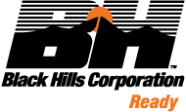

Black Hills Corp. Executes Definitive Agreements to Serve Google’s Planned Data Center in Cheyenne, Wyoming

•
Investing $1.8 billion in new company-owned natural gas generation
•
Providing up to 590 megawatts (MW) of grid-connected energy service and managing 2.1 gigawatts (GW) of third-party contracted resources through a private microgrid
•
Strong customer protections including no cost shifting to other customers
•
Return on generation investment and microgrid management fees are contracted to begin contributing to earnings in 2027, and expected to provide approximately $150 million of net income in 2030
•
Expected to generate approximately $2.4 billion of unlevered free cash flow through 2048, net of $1.8 billion of capital expenditures

RAPID CITY, S.D. — Oct. 6, 2026 — Black Hills Corp. (NYSE: BKH) today announced it has signed definitive agreements effective Sept. 30, 2026, with terms through 2048, to serve a planned Google data center to be constructed in Cheyenne, Wyoming. The negotiated agreements include a Large Power Contract Services Agreement (LPCSA) and a Generation Facilities Agreement (GFA).

The project, exclusive of additional transmission system expansion investments, is anticipated to be served by a total resource mix of 2.7 GW, including reserve margins, and is planned to begin taking energy service in late 2027 and ramp to the project’s peak load in 2030. Black Hills will provide up to 590 MW of grid-connected energy service through company-owned generation and market energy. In addition, Black Hills will manage the output of approximately 2.1 GW of Wyoming-based, third-party contracted resources through a privately managed microgrid under the company’s Large Power Contract Service (LPCS) tariff.

To support the project, Black Hills plans to invest $1.8 billion between 2027 and 2029 to construct 564 MW (nameplate capacity) of company-owned generation. The company expects to begin earning a return on its generation investment when construction begins in 2027. Revenue from microgrid management fees (MGMF) is anticipated to begin in late 2027 and increase based upon a contractually defined ramp schedule included in the LPCSA.

The project is expected to provide approximately $150 million of net income in 2030. Beyond 2030 and as contracted, the company will continue to earn MGMF and a return on its capital investment to be fully depreciated by 2048. The project is expected to deliver approximately $2.4 billion of unlevered free cash flow, net of $1.8 billion of generation capital investment. This cash flow will meaningfully strengthen the company’s financial profile, supporting a strong balance sheet, providing significant flexibility to finance the near-term investment, and creating substantial long-term flexibility for capital allocation.

“We are pleased to support Google’s planned investment in Wyoming while remaining firmly committed to providing safe, reliable, and cost-effective service to every customer,” said Linn Evans, president and CEO of Black Hills Corp. “The agreements demonstrate how innovative energy solutions can support economic growth while ensuring existing customers are protected. Importantly, these agreements and supporting regulatory mechanisms are structured so that Google bears all costs associated with serving the planned data center throughout the life of the project. We are excited that this project will create jobs, strengthen regional infrastructure, and contribute to Wyoming's long-term economic development."

Earning on generation investments and management of third-party resources through flexible Wyoming service model

To provide 590 MW of grid-connected service, Black Hills will construct and own through a non-regulated affiliate 564 MW (nameplate capacity) of new natural gas generation located at the company's existing Cheyenne Prairie Generating Station (CPGS) location. The remaining 26 MW will be supplied through a combination of market energy purchases and retail utility service provided under the company’s applicable industrial tariff.

In addition to recovering and earning a return on its generation investment, Black Hills will receive MGMF revenue for coordinating grid operations, reliability services, and energy dispatch across the portfolio of contracted resources and market energy purchases to serve the planned data center. The MGMF is a negotiated rate based upon a contracted minimum peak load expected to begin in 2027 and increase throughout the project's ramp period.

The company expects to finance the $1.8 billion generation investment through a combination of project-generated cash flow, debt, and other financing alternatives, and is evaluating a range of financing options, with a focus on earnings accretion while maintaining our solid investment-grade credit ratings. Strong cash flow, contractual pass-through of debt costs, cash return on the investment during construction, and a risk-adjusted return on the capital investment provide substantial flexibility in determining the optimal financing mix. Google has provided Black Hills with $399 million of refundable advances for the procurement of long lead-time equipment under the parties' generation reservation agreement. Black Hills expects to reimburse those advances by June 30, 2027.

Agreements provide benefits and protections for customers and shareholders

The project is structured to ensure that costs associated with serving the planned data center do not shift to existing retail customers. The agreements provide Black Hills with long-term revenue certainty and include multiple protections for customers and shareholders throughout the 2048 contract term.

Importantly, the announced agreements include the following base retail customer protections, among others:
•
Cost pass-through mechanisms – contract structures protect customers from costs associated with the planned data center while protecting returns from inflation, interest rate volatility, and other cost pressures;
•
Stranded asset risk protection – the GFA provides for full recovery of all generation capital investment over the contract term, protecting customers against risk of stranded assets;
•
Early termination protection – contract provisions safeguard customers and shareholders should the project terminate prior to the end of the agreements’ term; and
•
Credit protections – strong collateral and financial assurance requirements back the data center’s long-term commitments.

To further support this project, the company has completed or commenced regulatory matters, including the:

•
Robinson substation Certificate of Public Convenience and Necessity (CPCN) approved in May 2026;
•
Industrial siting permit for CPGS expansion filed in July 2026; and
•
Air quality permit for CPGS expansion approved in August 2026.

Additionally, the company is anticipating additional transmission investment to serve this project and other regional large-load opportunities that provide upside to its current capital plan. The company is advancing its transmission plans through the following regulatory filings:

•
Large Customer Transmission Cost Adjustment Mechanism (LCTCAM) filed in June 2026;
•
South Cheyenne Transmission Expansion CPCN filed in September 2026; and
•
Wyoming transmission expansion CPCN to be filed in the fourth quarter of 2026.

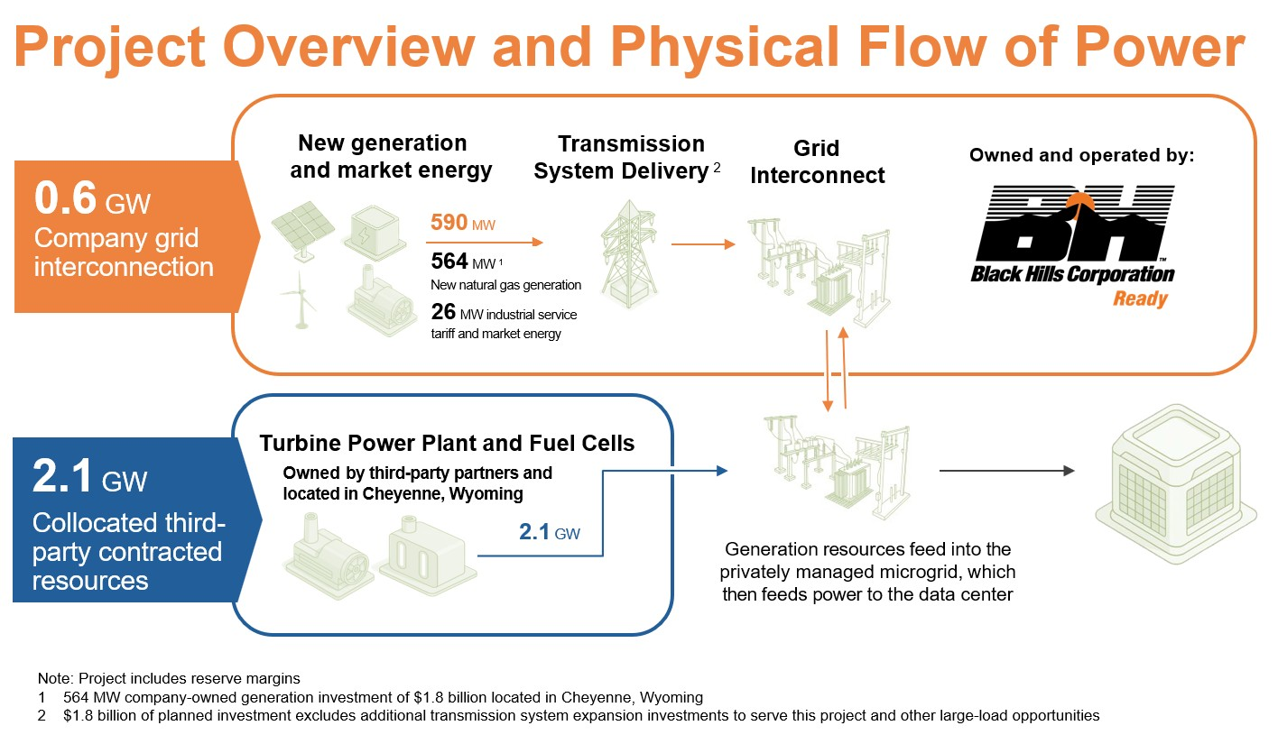

###

About Black Hills Corporation
Black Hills Corp. (NYSE: BKH) is a customer-focused, growth-oriented utility company with a tradition of improving life with energy and a vision to be the energy partner of choice. Based in Rapid City, South Dakota, the company serves 1.37 million natural gas and electric utility customers in eight states: Arkansas, Colorado, Iowa, Kansas, Montana, Nebraska, South Dakota and Wyoming. More information is available at www.blackhillscorp.com.

CAUTION REGARDING FORWARD-LOOKING STATEMENTS

This press release includes “forward-looking statements” as defined by the Securities and Exchange Commission. We make these forward-looking statements in reliance on the safe harbor protections provided under the Private Securities Litigation Reform Act of 1995. All statements, other than statements of historical facts, included in this press release that address activities, events, or developments that we expect, believe, or anticipate will or may occur in the future are forward-looking statements. This includes, without limitations, the expected timing, scope and benefits of the Cheyenne data center project, the timing and availability of equipment and milestone payments related thereto and the timing of regulatory or licensing approvals. These forward-looking statements are based on assumptions which we believe are reasonable based on current expectations and projections about future events and industry conditions and trends affecting our business. However, whether actual results and developments will conform to our expectations and predictions is subject to a number of risks and uncertainties that, among other things, could cause actual results to differ materially from those contained in the forward-looking statements, including without limitation, risks of securing the required regulatory or licensing approvals; contract risks, including conditions precedent, termination rights, and performance of our obligations; the risks that counterparties, including suppliers, contractors and other parties to our agreements, fail to perform their obligations; project development, financing, and operational risks that may impact our ability to realize the financial benefits expected; and other risk factors

described in Item 1A of Part I of our 2025 Annual Report on Form 10-K and other reports that we file with the SEC from time to time.

New factors that could cause actual results to differ materially from those described in forward-looking statements emerge from time-to-time, and it is not possible for us to predict all such factors, or the extent to which any such factor or combination of factors may cause actual results to differ from those contained in any forward-looking statement. We assume no obligation to update publicly any such forward-looking statements, whether as a result of new information, future events or otherwise.

Investor Relations
Sal Diaz
investorrelations@blackhillscorp.com

24-Hour Media Relations Line
888-242-3969

